  - Introduction to Project Theme:

In modern software development, managing changes to source code efficiently has become a critical requirement. As software applications increase in size and complexity, multiple developers often work simultaneously, making frequent updates, enhancements, and bug fixes. Without a structured mechanism to track these changes, maintaining consistency, reliability, and accuracy of the code becomes difficult. This challenge is effectively addressed by Version Control Systems (VCS), which maintain a record of file modifications and preserve historical versions of data.
The proposed project focuses on the development of a simplified web-based Version Control System, inspired by platforms such as GitHub. The objective is not to replicate the complete distributed architecture of Git, but to demonstrate the core principles of version management in a simplified and understandable manner. The system primarily concentrates on repository creation, file versioning, and commit history tracking, thereby reducing technical complexity while preserving the essential functionality of a version control system.
This project is designed as an academic prototype using modern web technologies. It provides users with a centralized platform to manage repositories and monitor file changes over time. By implementing this system, the project aims to bridge the gap between theoretical concepts of version control and their practical application in real-world software development environments.
The core objective of the project is to replace traditional manual processes with a structured, database system that stores all information in tabular format using a SQL database. This structured approach allows quick access to data, better monitoring and accurate maintenance of records. The system also supports easy generation of reports, which helps to analyse data, track performance and make informed decisions.
Additionally, the system emphasizes usability and accessibility by providing an intuitive web interface that allows users to perform version control operations without requiring advanced technical knowledge of command-line tools. Features such as user authentication, repository dashboards, commit logs, and file tracking mechanisms are integrated to ensure a smooth and organized workflow. Security measures are also considered to protect repository data and maintain user privacy. By combining simplicity with essential version control functionalities, the project serves as a practical learning tool for students and beginners, enabling them to understand collaborative development processes.
  - Working of System:

The Repository Management System follows a client–server architecture, where the frontend communicates with the backend using HTTP requests and responses. Users interact with the system through a web-based interface developed using HTML, CSS, and JavaScript, which ensures ease of access and usability.
The working of the system can be summarized as follows:
- Users access the system and perform authentication through a secure login process.
- After successful authentication, users are redirected to a structured dashboard.
- Users can create new repositories, upload files, and modify existing files through the dashboard interface.
Each user request is validated and processed by the backend developed using Python and the Flask framework.
Whenever a user modifies a file and saves the changes, the system creates a new version entry instead of overwriting the existing file. Each version contains:
- Version number
- Updated file content
- Commit message
- Timestamp
- Author information
All version-related data is stored securely in a MySQL database, allowing users to view, compare, or restore previous versions when required. This process effectively simulates the concept of commits found in traditional version control systems.
Furthermore, the system maintains a detailed commit history for every repository, enabling users to track the sequence of modifications made over time. Each operation performed by the user is logged to ensure transparency and accountability in the development process. The centralized database architecture ensures data consistency and prevents loss of information during concurrent operations. By automating version tracking and repository management, the system reduces manual effort, minimizes errors, and improves overall workflow efficiency. This structured working mechanism makes the platform reliable for academic demonstration and practical understanding of version control principles.

  - Need & Scope of Proposed System:

Need of the Proposed System -
The need for the proposed system arises from the growing importance of version control knowledge in the software development industry. Although professional platforms like GitHub provide advanced features, their internal working mechanisms are often complex and difficult for beginners to understand.

The proposed system addresses the following needs:
- Simplified understanding of version control concepts
- Centralized repository management
- Elimination of manual file backups
- Prevention of accidental data loss
- Improved tracking of file changes and updates
By maintaining a structured version history, the system improves accountability and enables users to revert to earlier versions whenever required.

Scope of the Proposed System -
The scope of the system is primarily limited to basic version control functionalities suitable for academic and learning purposes. These include:
- Repository creation and management
- File versioning
- Commit history tracking
- Centralized data storage
Although limited in scope, the system is designed to be scalable. In the future, it can be extended to include:
- Branching and merging
- Role-based access control
- Detailed activity logs
- Advanced version comparison tools
Thus, the system serves as a strong foundation for learning and future enhancements.

  - Objectives of the System:

The main objectives of the MiniGit system are:
- To provide a user-friendly platform for managing repositories without complex Git commands.
- To allow users to explore system features before registration through pre-register pages.
- To enable registered users to create, manage, and monitor repositories efficiently.
- To maintain a clear distinction between pre-register and post-register functionalities.
- To provide secure user authentication and authorization.
- To track user activity such as repository updates, commits, and issues.
- To offer a centralized dashboard for quick access to recent repositories and activity.
- To support basic collaboration features like issues and commits.
- To ensure data integrity and consistency using a structured database.
- To improve productivity for students and beginners learning version control concepts.
- To maintain a detailed commit history that allows users to review and restore previous versions of files.
- To provide an organized file versioning mechanism that prevents accidental data loss.
- To enable efficient repository navigation through structured categorization and search features.
- To generate activity reports that help users monitor their development progress.
- To implement role-based access control for better security and management of user permissions.
- To provide real-time feedback and notifications for important repository activities.
- To minimize manual errors by automating repository and version management processes.
- To ensure system scalability so that it can handle increasing repositories and users efficiently.
- To design an intuitive and responsive interface accessible across different devices and screen sizes.
- To serve as a practical educational tool that demonstrates the fundamental workflow of modern version control systems.
2.2 Software Requirement Specification:

1. Introduction:
i. Purpose of this Document:
This section defines the software requirements of MiniGit, a web-based repository management system that provides basic version control features through a simple and user-friendly interface.
ii. Scope of this Document:
MiniGit provides a streamlined platform where anyone can explore public repositories, view commit histories, and browse issues without needing an account. This makes it easy for users to discover projects and evaluate code before deciding to contribute. Once users register and authenticate securely, they unlock full repository management capabilities. Authenticated users can create both public and private repositories, initialize them with templates, and manage collaborators. They can also perform commits across branches, track changes through detailed histories, and handle merging. Additionally, the issue tracking system allows users to create, assign, and manage issues with labels, milestones, and comments, facilitating effective project management and team collaboration.

2. General Description:
MiniGit is a web-based repository management system built with Flask and MySQL. It allows users to register, create and manage repositories, track commits, and raise issues — similar to a lightweight GitHub. It includes an admin panel with live reporting on users, repositories, commits, issues, feedback, and repository popularity. The frontend uses a dark cyberpunk-style UI with Chart.js for data visualization, and data is loaded dynamically via a REST API pattern where JavaScript fetches JSON from Flask backend endpoints.

3. Functional Requirements:
i. Public User Requirements
- The system shall display home, features, demo, privacy policy, and help pages.
- The system shall allow users to submit feedback.
- The system shall allow users to register an account.
ii. Registered User Requirements
- The system shall allow secure user login and logout.
- The system shall display a dashboard with repositories and recent activity.
- The system shall allow users to create repositories, commits, and issues.
- The system shall allow users to view repositories and activity history.
- The system shall allow users to manage their profile
iii. Non-Functional Requirements
- The system shall provide fast response time.
- User data shall be securely stored and encrypted.
- The system shall be easy to use and reliable.

3.1 Context Level Diagram:
1. Registration
1. Registration
Admin
Client
2. Manage Repositories
3. Track User Activity
3. Create/Update/Delete Repos
2. Login
4. Create Commits/Issues
6. Track repo files
5. Handle Issues
4. Review Feedback
5. Visit Other repos

Web Application for Repository Services

6. Generate Reports

Database

3.2 Data Flow Diagram:
- First Level DFD for Admin:
1.0
Login
Admin
Admin

1.1
Manage client
Client

1.2
Repositories
Manage
Repositories

1.3
Manage
Commits
Commits

1.4
Issues
Manage
Issues

Track User
Activity

1.5
Activity

1.6
Reports

Commit
Popularity
Issues
Repositories
User
Feedback

- First Level Diagram for User:
Client
Cilent
Registeration
2.0
Client

2.1
Create
Repository
Repositories

2.2
Create
Commits/ Issues
Commits

2.3
Feedback
Feedback

3.3 Entity Relationship Diagram:
repo_id
name
Id
visibilty
owner_id
Track
Repos and
Their
Activity
1
Email
Repos
Admin
M
created_date
M
1
1
Password

Track Users
And Their
Activity
Create
And
Edit Repos

user_id
View and
Track Commits
full_name
email
username

M
password
Users
M
role
last_login
created_at
Create
And Manage
Commits
commit_id
Create
And Manage
Issues
M
repo_id
Commits
M
message
commit_date
author_id
commit_type

M
Issues

created_date
issue_id
created_by
issue_title
repo_id

3.4 System Requirement:
Hardware Requirement:
- Processor: Intel i5 8th Generation / AMD Ryzen 5.
- HDD / SSD: 512 GB.
- RAM: 8 GB.
- System Type: 64-bit operating system, x64-based processor.
- Monitor.
- Keyboard.
- Mouse.

Software Requirement:
- Operating System: Linux or Windows.
- Web Browser: Chrome or Edge.
- Text Editor: Visual Studio Code.
- Database: MySQL.
- Front-end: HTML, CSS, JavaScript.
- Back-end: Python.

  - Database Design (Data Dictionary):

- Table name: Users
Sr. No. | Fields | Data type | Size | Description
1 | User_id | Int |  | To store the user id
2 | Full_name | Varchar | 100 | To store the name
3 | Username | Varchar | 50 | To store the username
4 | Email | Varchar | 100 | To store the email
5 | Password | Varchar | 255 | To store the password
6 | Created_at | Timestamp |  | To store the creation date
7 | Last_login | Timestamp |  | To store the last login

- Table name: Repositories
Sr. No. | Fields | Data type | Size | Description
1 | Repo_id | Int |  | To store the repo id
2 | Repo_name | Varchar | 100 | To store the repo name
3 | Owner_id | Int |  | To store the owner id
4 | Visibility | Enum |  | To store the visibility
5 | Created_date | Timestamp |  | To store the created date

- Table name: Commits
Sr. No. | Fields | Data type | Size | Description
1 | Commit_id | Int |  | To store the commit id
2 | Repo_id | Int |  | To store the repo id
3 | Commit_message | Varchar | 500 | To store the commit message
4 | Author_id | Int |  | To store the author id
5 | Commit_type | Enum |  | To store the commit type
6 | Commit_date | Timestamp |  | To store the commit date

- Table name: Issues
Sr. No. | Fields | Data type | Size | Description
1 | Issue_id | Int |  | To store the issue id
2 | Repo_id | Int |  | To store the repo id
3 | Issue_title | Varchar | 200 | To store the issue title
4 | Description | Text |  | To store the issue description
5 | Created_by | Int |  | To store the creator id
6 | Status | Enum |  | To store the status
7 | Priority | Enum |  | To store the priority
8 | Created_date | Timestamp |  | To store the created date

- Table name: Repo Views
Sr. No. | Fields | Data type | Size | Description
1 | View_id | Int |  | To store the view id
2 | Repo_id | Int |  | To store the repo id
3 | User_id | Int |  | To store the user id
4 | Viewed_at | Timestamp |  | To store the view time

- Table name: Activity Logs
Sr. No. | Fields | Data type | Size | Description
1 | Activity_id | Int |  | To store the activity id
2 | User_id | Int |  | To store the user id
3 | Repo_id | Int |  | To store the repo id
4 | Activity_message | Varchar | 255 | To store the activity message
5 | Created_at | Timestamp |  | To store the creation time

- Table name: Feedback
Sr. No. | Fields | Data type | Size | Description
1 | Feedback_id | Int |  | To store the feedback id
2 | Name | Varchar | 100 | To store the name
3 | Category | Varchar | 50 | To store the Category
4 | Experience | Varchar | 20 | To store the experience
5 | Message | Text |  | To store the message
6 | Created_at | Timestamp |  | To store the creation time

  - Input Design:
- Without data:
register.html:
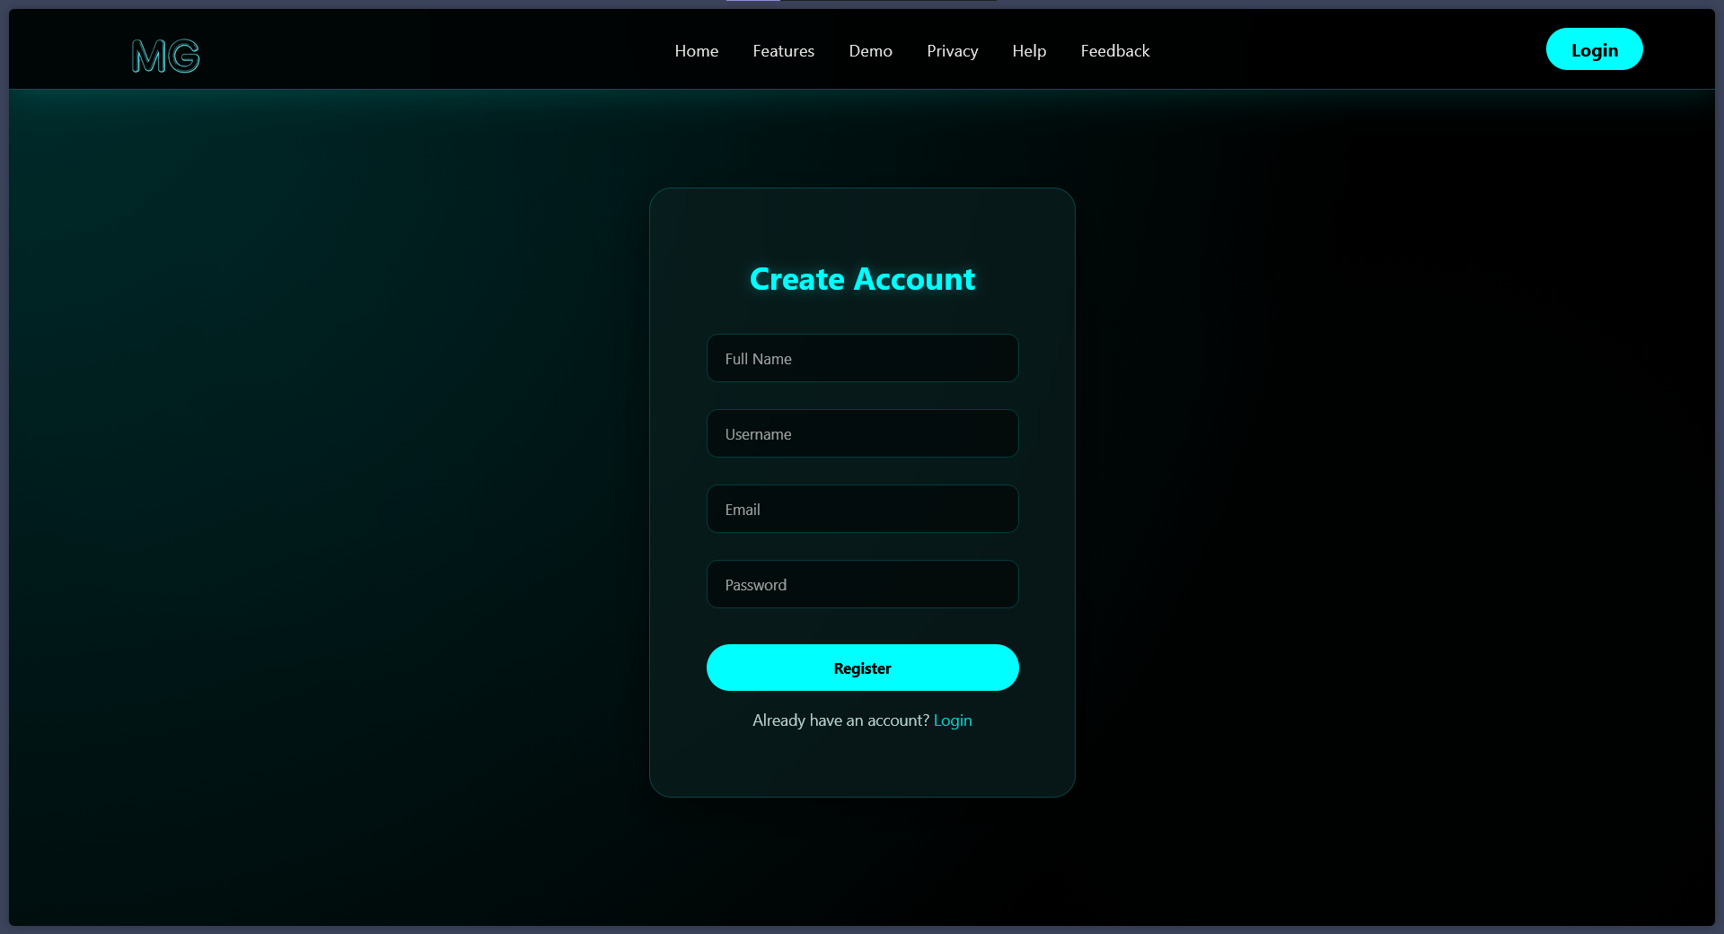
- Source Code:
<!DOCTYPE html>
<html lang="en">
<head>
<meta charset="UTF-8">
<title>Register | MiniGit</title>
<link rel="stylesheet" href="{{ url_for('static', filename='css/login.css') }}">
</head>
<body>
<!-- HEADER -->
<header class="header">
<div class="brand">
<img src="{{ url_for('static', filename='/images/blue.png') }}" width="150px" height="150px"></div>
</div>

<nav class="nav">
<a href="{{ url_for('home') }}" class="{% if active_page == 'home' %}active{% endif %}">Home</a>
<a href="{{ url_for('features') }}" class="{% if active_page == 'features' %}active{% endif %}">Features</a>
<a href="{{ url_for('demo') }}" class="{% if active_page == 'demo' %}active{% endif %}">Demo</a>
<a href="{{ url_for('privacy') }}" class="{% if active_page == 'privacy' %}active{% endif %}">Privacy</a>
<a href="{{ url_for('help') }}" class="{% if active_page == 'help' %}active{% endif %}">Help</a>
<a href="{{ url_for('feedback') }}" class="{% if active_page == 'feedback' %}active{% endif %}">Feedback</a>
</nav>
<a href="{{ url_for('login') }}" class="login">Login</a>
</header>
<!-- REGISTER FORM -->
<div class="login-container">
<div class="login-card">
<h2>Create Account</h2>
<form method="POST" action="/register">
<input type="text" name="full_name" placeholder="Full Name" required>
<input type="text" name="username" placeholder="Username" required>
<input type="email" name="email" placeholder="Email" required>
<input type="password" name="password" placeholder="Password" required>
<button type="submit">Register</button>
</form>
<p>Already have an account? <a href="{{ url_for('login') }}" style="color: cyan; text-decoration: none;">Login</a>
</p>
</div>
</div>
</body>
</html>

login.html:
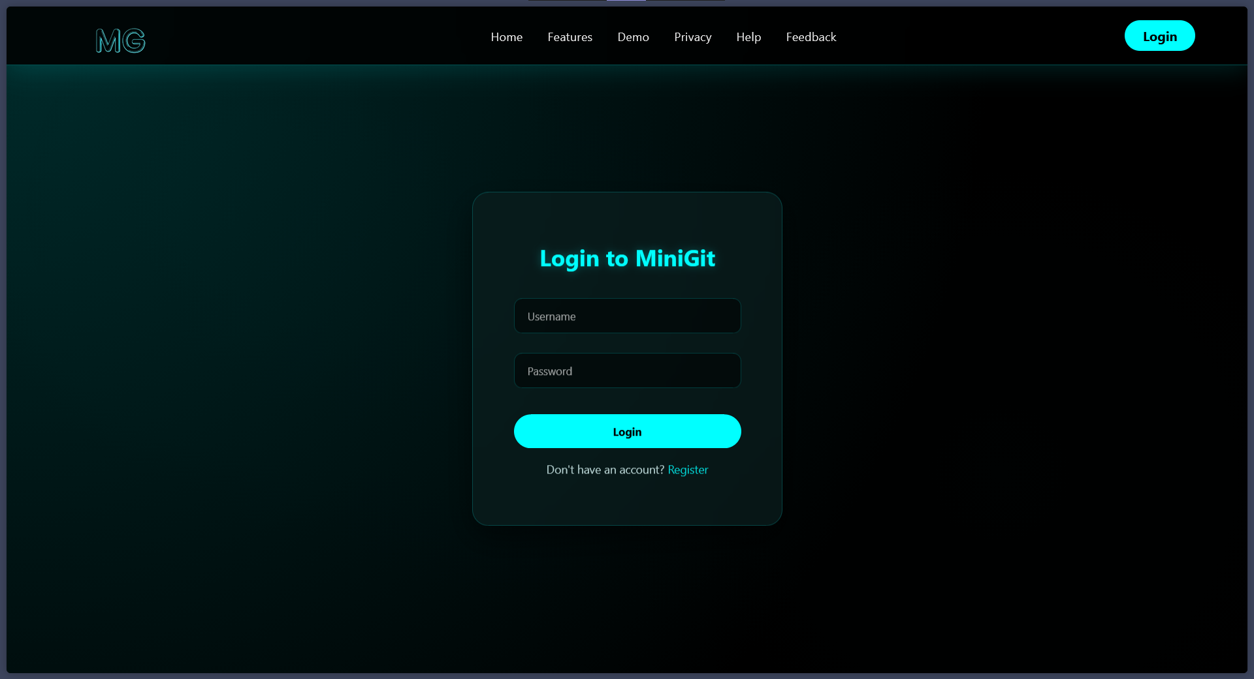
- Source Code:
<!DOCTYPE html>
<html lang="en">

<head>
<meta charset="UTF-8">
<title>Login | MiniGit</title>
<link rel="stylesheet" href="/static/css/login.css">
</head>

<body>

<!-- HEADER -->
<header class="header">
<div class="brand">
<img src="{{ url_for('static', filename='/images/blue.png') }}" width="150px" height="150px"></div>
</div>

<nav class="nav">
<a href="{{ url_for('home') }}" class="{% if active_page == 'home' %}active{% endif %}">Home</a>
<a href="{{ url_for('features') }}" class="{% if active_page == 'features' %}active{% endif %}">Features</a>
<a href="{{ url_for('demo') }}" class="{% if active_page == 'demo' %}active{% endif %}">Demo</a>
<a href="{{ url_for('privacy') }}" class="{% if active_page == 'privacy' %}active{% endif %}">Privacy</a>
<a href="{{ url_for('help') }}" class="{% if active_page == 'help' %}active{% endif %}">Help</a>
<a href="{{ url_for('feedback') }}" class="{% if active_page == 'feedback' %}active{% endif %}">Feedback</a>
</nav>

<a href="{{ url_for('login') }}" class="login">Login</a>

</header>
<!-- LOGIN FORM -->
<div class="login-container">
<div class="login-card">
<h2>Login to MiniGit</h2>
<form method="POST" action="/login">
<input type="text" name="username" placeholder="Username" required>
<input type="password" name="password" placeholder="Password" required>
<button type="submit">Login</button>
</form>
<p>Don't have an account? <a href="/register" style="color: cyan; text-decoration: none;">Register</a></p>
</div>
</div>

</body>

</html>

create_repo.html:
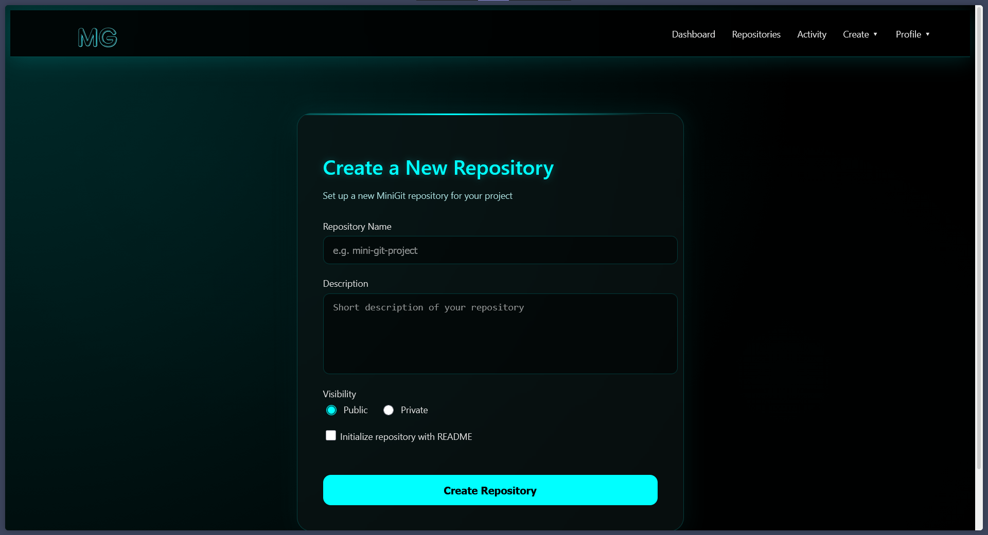
- Source Code:
<!DOCTYPE html>
<html lang="en">
<head>
<meta charset="UTF-8">
<title>Create Repository | MiniGit</title>
<link rel="stylesheet" href="{{ url_for('static', filename='css/create_repo.css') }}">
</head>
<body>

<!-- ================= AUTH NAVBAR ================= -->
<header class="auth-header">
<div class="auth-brand">
<img src="{{ url_for('static', filename='/images/blue.png') }}" width="150px" height="150px"></div>
</div>

<nav class="auth-nav">
<a href="/dashboard" class="{% if active_page == 'dashboard' %}active{% endif %}">Dashboard</a>
<a href="/repositories" class="{% if active_page == 'repositories' %}active{% endif %}">Repositories</a>
<a href="/activity" class="{% if active_page == 'activity' %}active{% endif %}">Activity</a>

<!-- Create Dropdown -->
<div class="dropdown">
<span>Create ▾</span>
<div class="dropdown-menu">
<a href="/create-repo" class="{% if active_page == 'create-repo' %}active{% endif %}">New Repository</a>
<a href="/create-issue" class="{% if active_page == 'create-issue' %}active{% endif %}">New Issue</a>
<a href="/create-commit" class="{% if active_page == 'create-commit' %}active{% endif %}">New Commit</a>
</div>
</div>

<!-- Profile Dropdown -->
<div class="dropdown profile-dropdown">
<span class="{% if active_page in ['profile', 'my-repos', 'activity'] %}active{% endif %}">Profile ▾</span>
<div class="dropdown-menu">
<a href="/profile" class="{% if active_page == 'profile' %}active{% endif %}">View Profile</a>
<a href="/repositories" class="{% if active_page == 'my-repos' %}active{% endif %}">My Repositories</a>
<a href="/activity" class="{% if active_page == 'activity' %}active{% endif %}">My Activity</a>
<a href="/logout" class="logout">Logout</a>
</div>
</div>
</nav>

</header>

<!-- ================= CREATE REPO SECTION ================= -->
<section class="create-container">
<div class="repo-card">
<h1>Create a New Repository</h1>
<p class="subtitle">
Set up a new MiniGit repository for your project
</p>

<form method="POST" action="/create-repo">
<div class="form-group">
<label>Repository Name</label>
<input
type="text"
<!-- name="repo_name" ADD THIS
placeholder="e.g. mini-git-project"
required
>
</div>

<div class="form-group">
<label>Description</label>
<textarea
name="description" ADD THIS
placeholder="Short description of your repository"
></textarea>
</div>

<div class="form-group">
<label>Visibility</label>
<div class="radio-group">
<label>
<input type="radio" name="visibility" value="public" checked> <!-- ADD value="public" -->
Public
</label>
<label>
<input type="radio" name="visibility" value="private"> <!-- ADD value="private" -->
Private
</label>
</div>
</div>

<div class="form-group checkbox">
<label>
<input type="checkbox" name="init_readme" value="yes"> <!-- ADD name="init_readme" -->
Initialize repository with README
</label>
</div>

<button type="submit" class="create-btn">
Create Repository
</button>
</form>
</div>
</section>

</body>
</html>

create_issue:
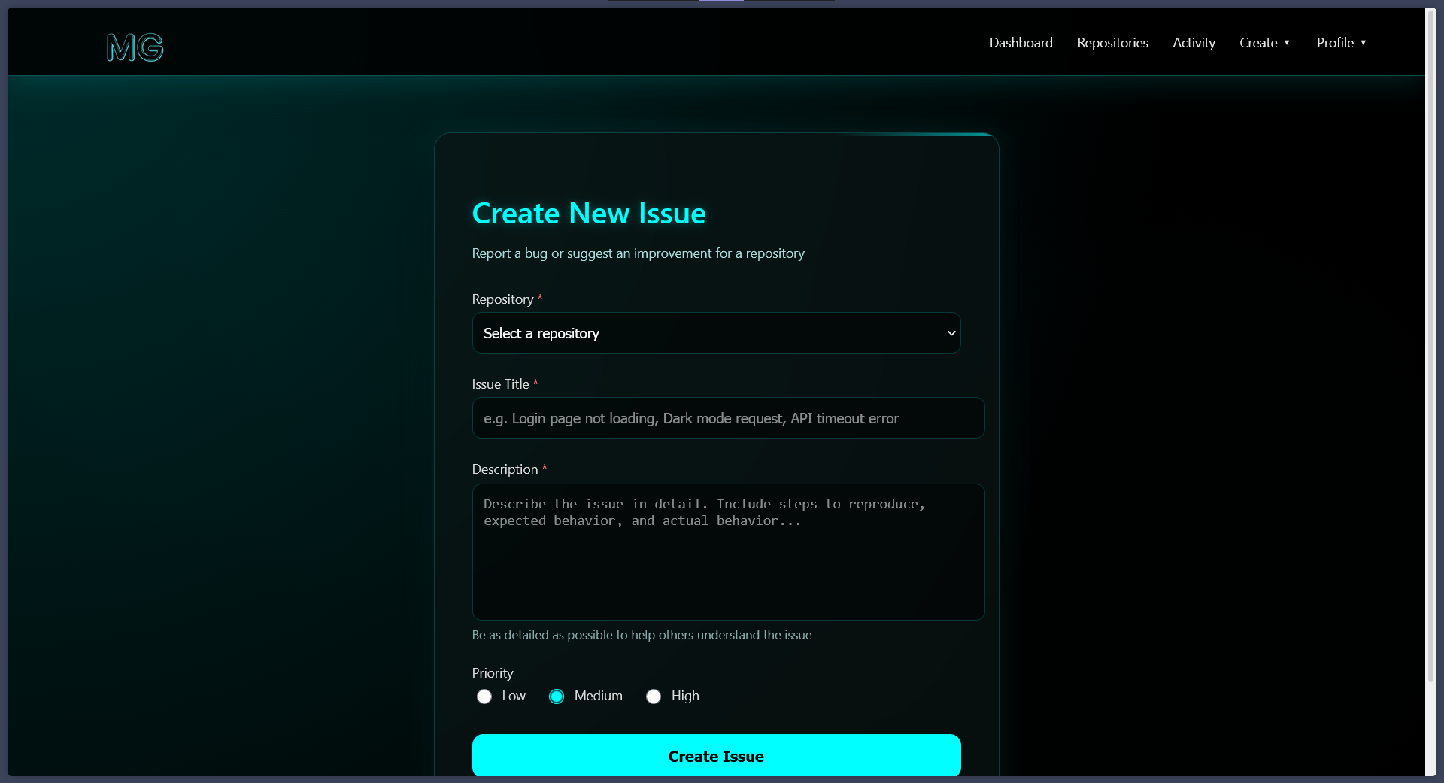
- Source Code:
<!DOCTYPE html>
<html lang="en">
<head>
<meta charset="UTF-8">
<title>Create Issue | MiniGit</title>
<link rel="stylesheet" href="{{ url_for('static', filename='css/create_issue.css') }}">
</head>
<body>

<!-- ================= AUTH NAVBAR ================= -->
<header class="auth-header">
<div class="auth-brand">
<img src="{{ url_for('static', filename='/images/blue.png') }}" width="150px" height="150px">
</div>

<nav class="auth-nav">
<a href="/dashboard" class="{% if active_page == 'dashboard' %}active{% endif %}">Dashboard</a>
<a href="/repositories" class="{% if active_page == 'repositories' %}active{% endif %}">Repositories</a>
<a href="/activity" class="{% if active_page == 'activity' %}active{% endif %}">Activity</a>

<!-- Create Dropdown -->
<div class="dropdown">
<span>Create ▾</span>
<div class="dropdown-menu">
<a href="/create-repo" class="{% if active_page == 'create-repo' %}active{% endif %}">New Repository</a>
<a href="/create-issue" class="{% if active_page == 'create-issue' %}active{% endif %}">New Issue</a>
<a href="/create-commit" class="{% if active_page == 'create-commit' %}active{% endif %}">New Commit</a>
</div>
</div>

<!-- Profile Dropdown -->
<div class="dropdown profile-dropdown">
<span class="{% if active_page in ['profile', 'my-repos', 'activity'] %}active{% endif %}">Profile ▾</span>
<div class="dropdown-menu">
<a href="/profile" class="{% if active_page == 'profile' %}active{% endif %}">View Profile</a>
<a href="/repositories" class="{% if active_page == 'my-repos' %}active{% endif %}">My Repositories</a>
<a href="/activity" class="{% if active_page == 'activity' %}active{% endif %}">My Activity</a>
<a href="/logout" class="logout">Logout</a>
</div>
</div>
</nav>
</header>

<!-- ================= CREATE ISSUE SECTION ================= -->
<section class="issue-container">
<div class="issue-card">
<h1>Create New Issue</h1>
<p class="subtitle">
Report a bug or suggest an improvement for a repository
</p>

<form method="POST" action="/create-issue">

<div class="form-group">
<label>Repository <span style="color: #ff6b6b;">*</span></label>
<select name="repo_id" required>
<option value="">Select a repository</option>
{% for repo in repositories %}
<option value="{{ repo.repo_id }}">{{ repo.repo_name }}</option>
{% endfor %}
</select>
</div>

<div class="form-group">
<label>Issue Title <span style="color: #ff6b6b;">*</span></label>
<input
type="text"
name="issue_title"
placeholder="e.g. Login page not loading, Dark mode request, API timeout error"
required
>
</div>

<div class="form-group">
<label>Description <span style="color: #ff6b6b;">*</span></label>
<textarea
name="description"
placeholder="Describe the issue in detail. Include steps to reproduce, expected behavior, and actual behavior..."
required
></textarea>
<small style="color: #88aaaa; display: block; margin-top: 5px;">
Be as detailed as possible to help others understand the issue
</small>
</div>

<div class="form-group">
<label>Priority</label>
<div class="radio-group">
<label class="radio-label">
<input type="radio" name="priority" value="low">
<span>Low</span>
</label>
<label class="radio-label">
<input type="radio" name="priority" value="medium" checked>
<span>Medium</span>
</label>
<label class="radio-label">
<input type="radio" name="priority" value="high">
<span>High</span>
</label>
</div>
</div>

<button type="submit" class="create-btn">
Create Issue
</button>

</form>
</div>
</section>

</body>
</html>

create_commit:
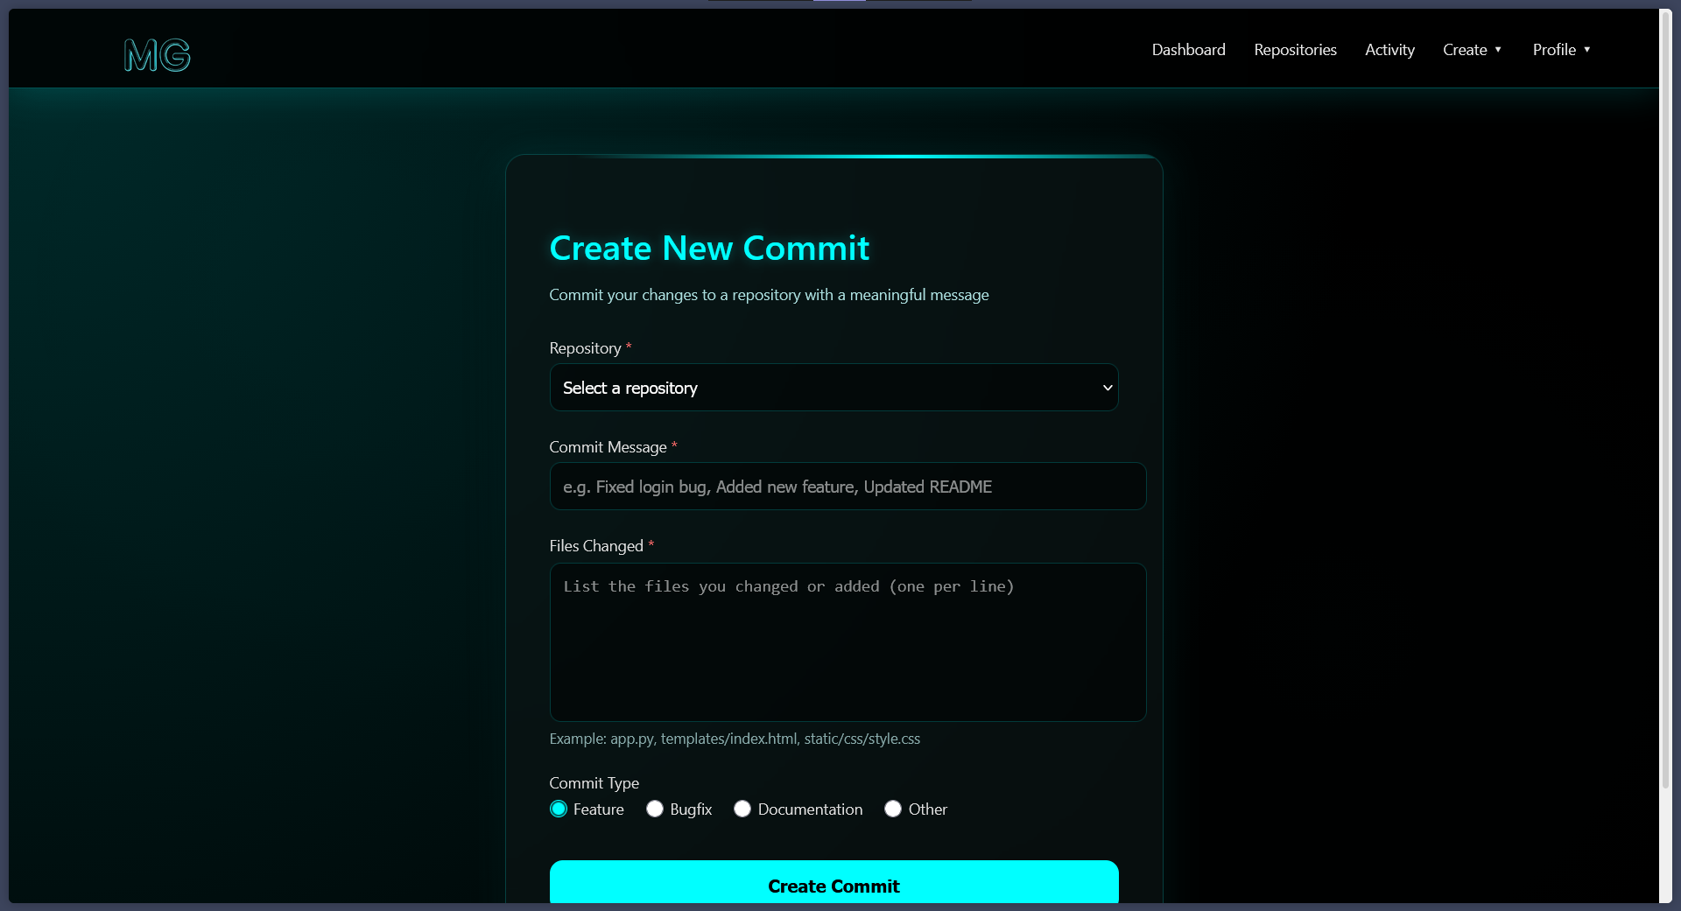
- Source Code:
<!DOCTYPE html>
<html lang="en">
<head>
<meta charset="UTF-8">
<title>Create Commit | MiniGit</title>
<link rel="stylesheet" href="{{ url_for('static', filename='css/create_commit.css') }}">
</head>
<body>

<!-- ================= AUTH NAVBAR ================= -->
<header class="auth-header">
<div class="auth-brand">
<img src="{{ url_for('static', filename='/images/blue.png') }}" width="150px" height="150px">
</div>

<nav class="auth-nav">
<a href="/dashboard" class="{% if active_page == 'dashboard' %}active{% endif %}">Dashboard</a>
<a href="/repositories" class="{% if active_page == 'repositories' %}active{% endif %}">Repositories</a>
<a href="/activity" class="{% if active_page == 'activity' %}active{% endif %}">Activity</a>

<!-- Create Dropdown -->
<div class="dropdown">
<span>Create ▾</span>
<div class="dropdown-menu">
<a href="/create-repo" class="{% if active_page == 'create-repo' %}active{% endif %}">New Repository</a>
<a href="/create-issue" class="{% if active_page == 'create-issue' %}active{% endif %}">New Issue</a>
<a href="/create-commit" class="{% if active_page == 'create-commit' %}active{% endif %}">New Commit</a>
</div>
</div>

<!-- Profile Dropdown -->
<div class="dropdown profile-dropdown">
<span class="{% if active_page in ['profile', 'my-repos', 'activity'] %}active{% endif %}">Profile ▾</span>
<div class="dropdown-menu">
<a href="/profile" class="{% if active_page == 'profile' %}active{% endif %}">View Profile</a>
<a href="/repositories" class="{% if active_page == 'my-repos' %}active{% endif %}">My Repositories</a>
<a href="/activity" class="{% if active_page == 'activity' %}active{% endif %}">My Activity</a>
<a href="/logout" class="logout">Logout</a>
</div>
</div>
</nav>
</header>

<!-- ================= CREATE COMMIT SECTION ================= -->
<section class="commit-container">
<div class="commit-card">
<h1>Create New Commit</h1>
<p class="subtitle">
Commit your changes to a repository with a meaningful message
</p>

<form method="POST" action="/create-commit">

<div class="form-group">
<label>Repository <span style="color: #ff6b6b;">*</span></label>
<select name="repo_id" required>
<option value="">Select a repository</option>
{% for repo in repositories %}
<option value="{{ repo.repo_id }}">{{ repo.repo_name }}</option>
{% endfor %}
</select>
</div>

<div class="form-group">
<label>Commit Message <span style="color: #ff6b6b;">*</span></label>
<input
type="text"
name="commit_message"
placeholder="e.g. Fixed login bug, Added new feature, Updated README"
required
>
</div>

<div class="form-group">
<label>Files Changed <span style="color: #ff6b6b;">*</span></label>
<textarea
name="files_changed"
placeholder="List the files you changed or added (one per line)"
required
></textarea>
<small style="color: #88aaaa; display: block; margin-top: 5px;">Example: app.py, templates/index.html, static/css/style.css</small>
</div>

<div class="form-group">
<label>Commit Type</label>
<div class="radio-group">
<label class="radio-label">
<input type="radio" name="commit_type" value="feature" checked>
<span>Feature </span>
</label>
<label class="radio-label">
<input type="radio" name="commit_type" value="bugfix">
<span>Bugfix </span>
</label>
<label class="radio-label">
<input type="radio" name="commit_type" value="documentation">
<span>Documentation </span>
</label>
<label class="radio-label">
<input type="radio" name="commit_type" value="other">
<span>Other </span>
</label>
</div>
</div>

<button type="submit" class="create-btn">
Create Commit
</button>

</form>
</div>
</section>

</body>
</html>

repositories.html:
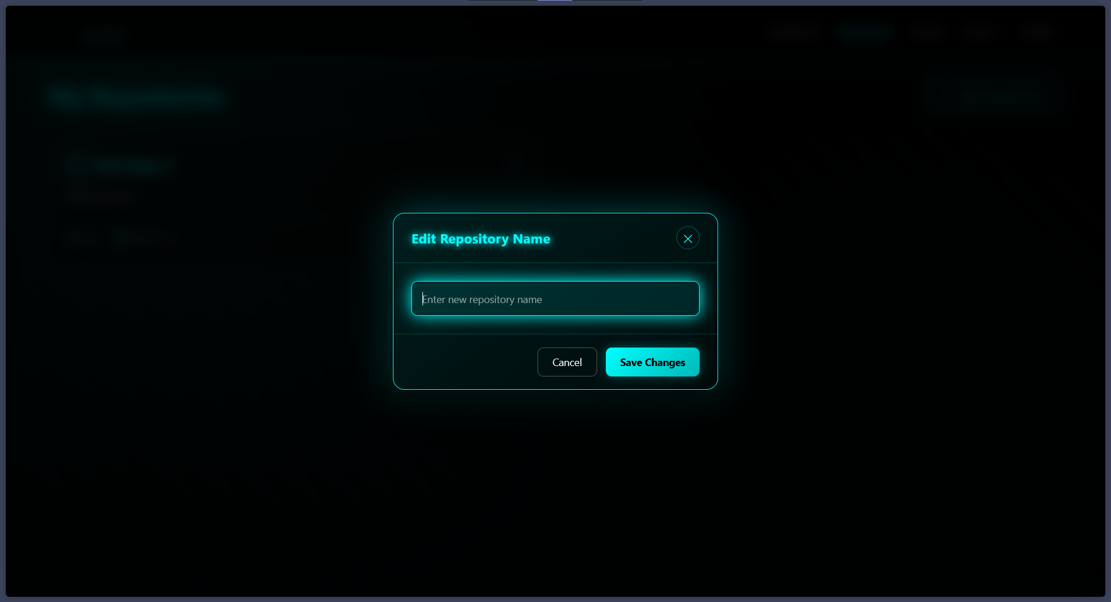
- Source Code:
<!doctype html>
<html lang="en">
<head>
<meta charset="UTF-8" />
<title>Repositories | MiniGit</title>
<link
rel="stylesheet"
href="{{ url_for('static', filename='css/repositories.css') }}"
/>
</head>
<body>
<!-- ================= AUTH NAVBAR ================= -->
<header class="auth-header">
<div class="auth-brand">
<img src="{{ url_for('static', filename='/images/blue.png') }}" width="150px" height="150px">
</div>

<nav class="auth-nav">
<a href="/dashboard" class="{% if active_page == 'dashboard' %}active{% endif %}">Dashboard</a>
<a href="/repositories" class="{% if active_page == 'repositories' %}active{% endif %}">Repositories</a>
<a href="/activity" class="{% if active_page == 'activity' %}active{% endif %}">Activity</a>

<!-- Create Dropdown -->
<div class="dropdown">
<span>Create ▾</span>
<div class="dropdown-menu">
<a href="/create-repo" class="{% if active_page == 'create-repo' %}active{% endif %}">New Repository</a>
<a href="/create-issue" class="{% if active_page == 'create-issue' %}active{% endif %}">New Issue</a>
<a href="/create-commit" class="{% if active_page == 'create-commit' %}active{% endif %}">New Commit</a>
</div>
</div>
<script>
// Toggle dropdown menu
function toggleDropdown(button) {
const dropdown = button.nextElementSibling;
dropdown.classList.toggle('show');

// Close other dropdowns
document.querySelectorAll('.repo-menu.show').forEach(menu => {
if (menu !== dropdown) menu.classList.remove('show');
});
}

// Close dropdowns when clicking outside
document.addEventListener('click', function(event) {
if (!event.target.closest('.repo-dropdown')) {
document.querySelectorAll('.repo-menu.show').forEach(menu => {
menu.classList.remove('show');
});
}
});

// Edit repository
let currentEditRepoId = null;

function editRepo(repoId) {
currentEditRepoId = repoId;
const modal = document.getElementById('editModal');

// Get current repo name
const repoCard = document.querySelector(`.repository-card[data-repo-id="${repoId}"]`);
const currentName = repoCard.querySelector('h3 a').textContent;

document.getElementById('newRepoName').value = currentName;
modal.style.display = 'flex';

// Close any open dropdowns
document.querySelectorAll('.repo-menu.show').forEach(menu => {
menu.classList.remove('show');
});
}

// Save repository name
function saveRepoName() {
const newName = document.getElementById('newRepoName').value.trim();

if (!newName) {
alert('Repository name cannot be empty');
return;
}

if (newName.length < 3) {
alert('Repository name must be at least 3 characters');
return;
}

// Show loading state
const saveBtn = document.querySelector('.modal-btn.save');
const originalText = saveBtn.textContent;
saveBtn.textContent = 'Saving...';
saveBtn.disabled = true;

// Simulate successful save for demo
setTimeout(() => {
// Update the repo name in the card
const repoCard = document.querySelector(`.repository-card[data-repo-id="${currentEditRepoId}"]`);
const repoLink = repoCard.querySelector('h3 a');
repoLink.textContent = newName;
repoCard.dataset.repoName = newName;

closeModal();
alert('Repository name updated successfully!');

saveBtn.textContent = originalText;
saveBtn.disabled = false;
}, 1000);
}

// Toggle visibility
function toggleVisibility(repoId) {
const repoCard = document.querySelector(`.repository-card[data-repo-id="${repoId}"]`);
const currentVisibility = repoCard.dataset.visibility;
const newVisibility = currentVisibility === 'public' ? 'private' : 'public';

// Show loading state
const visibilityLink = repoCard.querySelector('.visibility-text');
const originalText = visibilityLink.textContent;
visibilityLink.textContent = 'Updating...';

// Simulate successful toggle for demo
setTimeout(() => {
// Update visibility in card
repoCard.dataset.visibility = newVisibility;

// Update badge
const badge = repoCard.querySelector('.visibility-badge');
badge.className = `visibility-badge ${newVisibility}`;
badge.textContent = newVisibility;

// Update dropdown option text
const newText = newVisibility === 'public' ? 'Make Private' : 'Make Public';
visibilityLink.textContent = newText;

alert(`Repository is now ${newVisibility}`);

// Close dropdown
document.querySelectorAll('.repo-menu.show').forEach(menu => {
menu.classList.remove('show');
});
}, 500);
}

// Delete repository
// Delete repository
function deleteRepo(repoId) {
if (confirm('⚠️ Are you sure you want to delete this repository?\n\nThis action cannot be undone. All commits and issues will be permanently deleted.')) {
const repoCard = document.querySelector(`.repository-card[data-repo-id="${repoId}"]`);

// Show deleting state
repoCard.style.opacity = '0.5';
repoCard.style.pointerEvents = 'none';

fetch(`/api/repo/${repoId}/delete`, {
method: 'POST',
headers: { 'Content-Type': 'application/json' }
})
.then(response => response.json())
.then(data => {
if (data.success) {
// Remove the card with animation
repoCard.style.transition = 'all 0.3s ease';
repoCard.style.transform = 'scale(0.8)';
repoCard.style.opacity = '0';

setTimeout(() => {
repoCard.remove();

// Check if no repos left
const remainingCards = document.querySelectorAll('.repository-card');
if (remainingCards.length === 0) {
location.reload(); // Reload to show empty state
} else {
showNotification('Repository deleted successfully', 'success');
}
}, 300);
} else {
repoCard.style.opacity = '1';
repoCard.style.pointerEvents = 'auto';
showNotification(data.error || 'Could not delete repository', 'error');
}
})
.catch(error => {
console.error('Error:', error);
repoCard.style.opacity = '1';
repoCard.style.pointerEvents = 'auto';
showNotification('Failed to delete repository', 'error');
});

// Close dropdown
document.querySelectorAll('.repo-menu.show').forEach(menu => {
menu.classList.remove('show');
});
}
}

// Close modal
function closeModal() {
document.getElementById('editModal').style.display = 'none';
document.getElementById('newRepoName').value = '';
currentEditRepoId = null;
}

// Close modal when clicking outside
window.onclick = function(event) {
const modal = document.getElementById('editModal');
if (event.target === modal) {
closeModal();
}
}

// Handle Enter key in modal
document.addEventListener('keydown', function(event) {
if (event.key === 'Escape' && document.getElementById('editModal').style.display === 'flex') {
closeModal();
}
if (event.key === 'Enter' && document.getElementById('editModal').style.display === 'flex') {
saveRepoName();
}
});
</script>
</body>
</html>

- With data:
register.html:
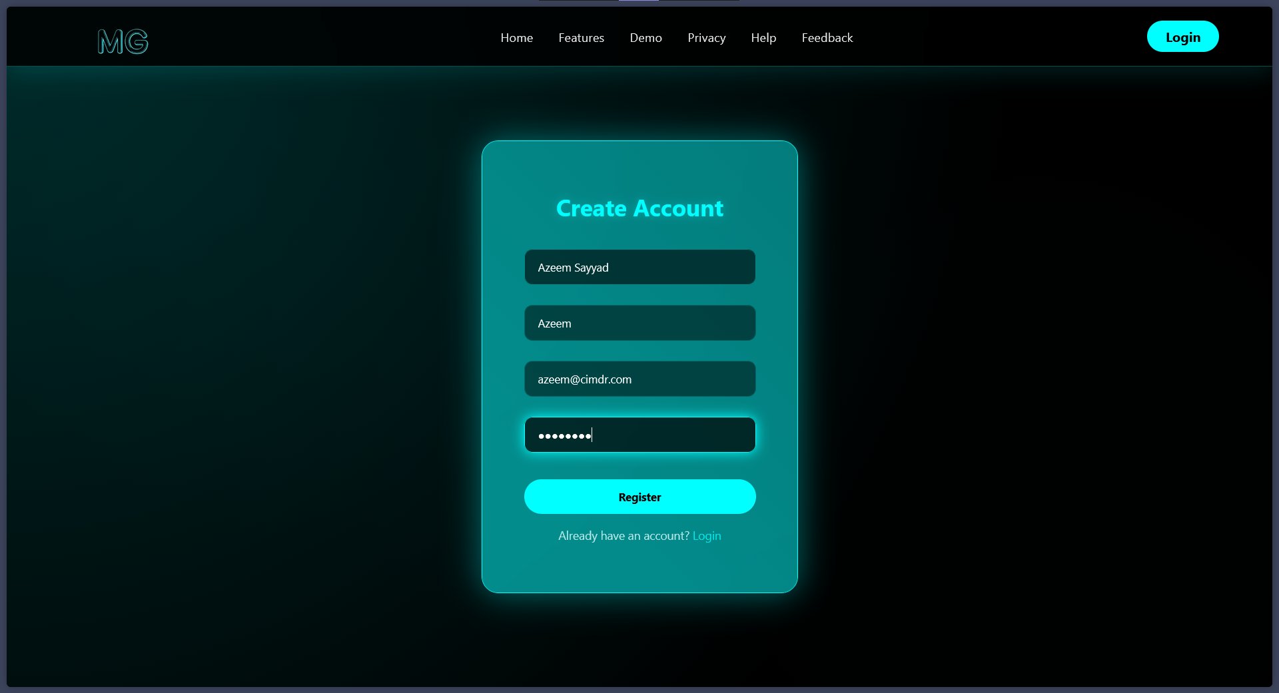

login.html:
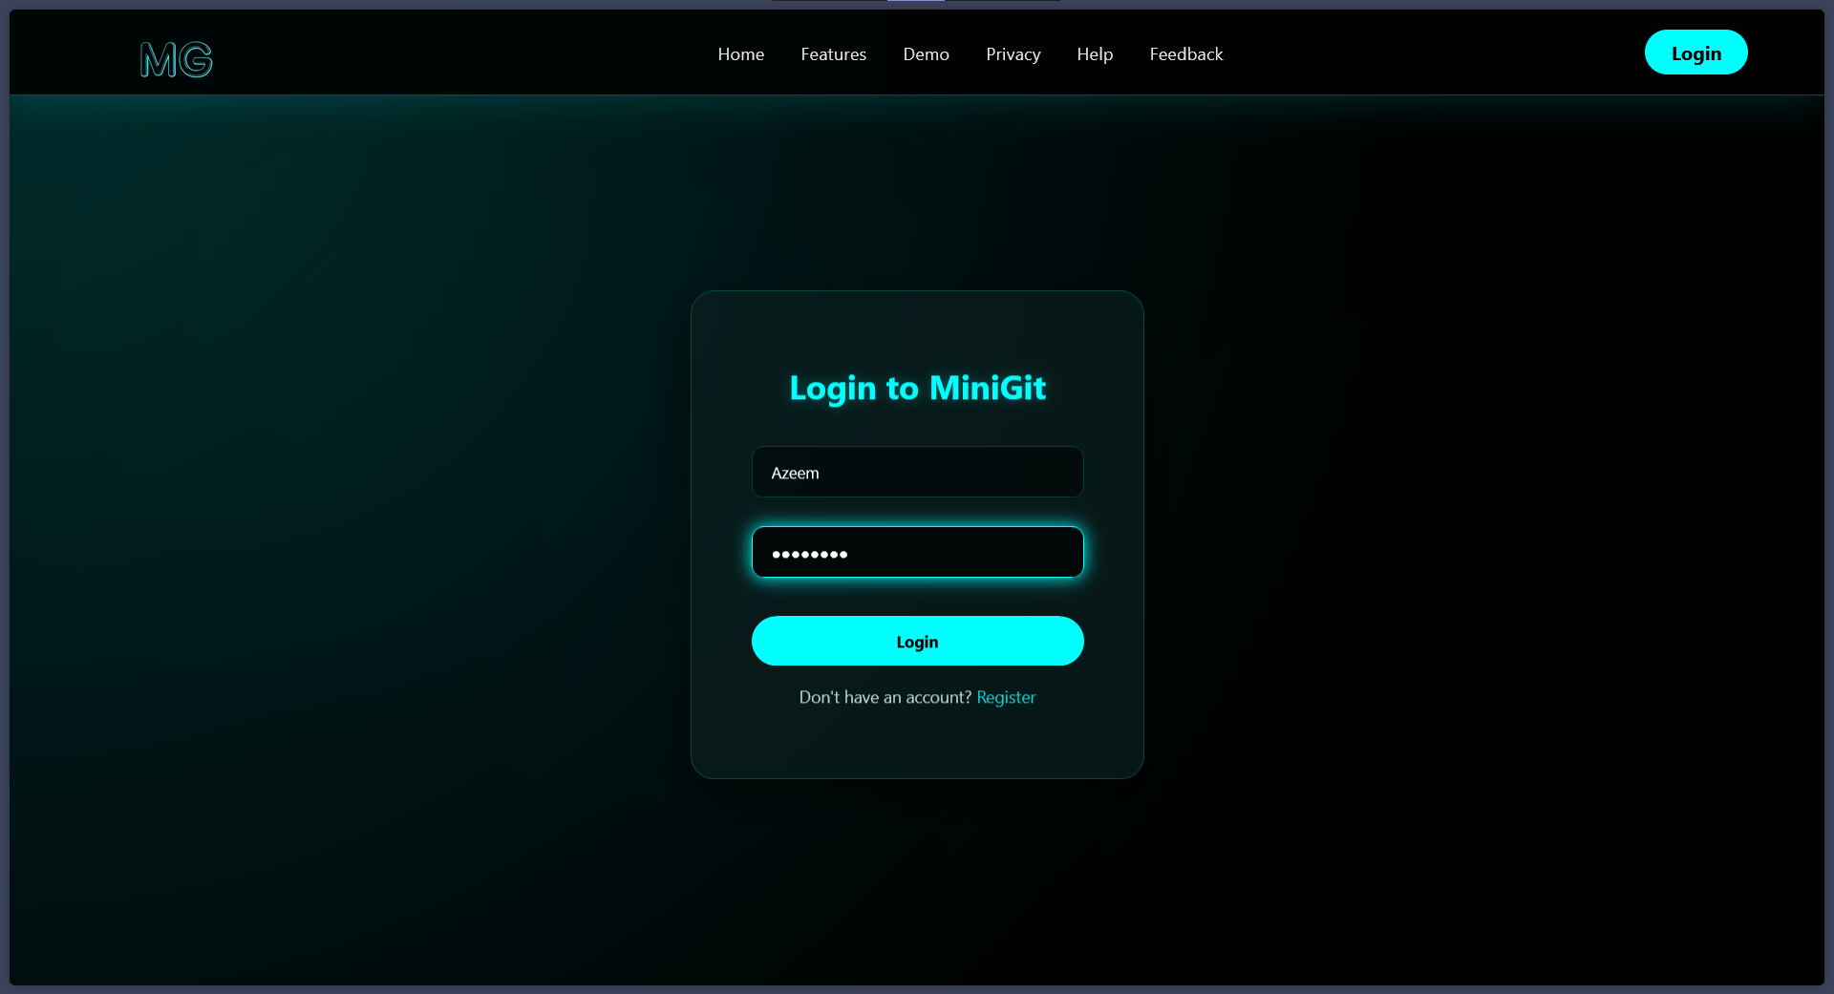

create_repo.html:
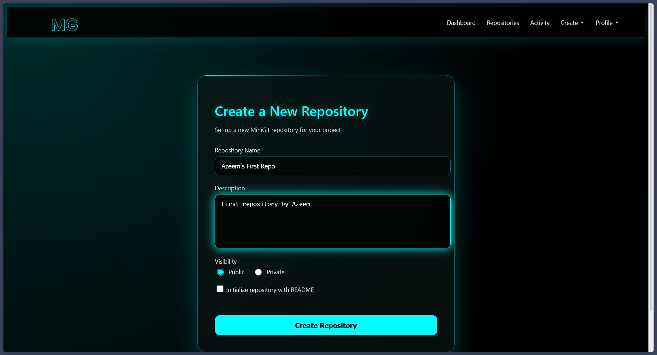

create_issue:
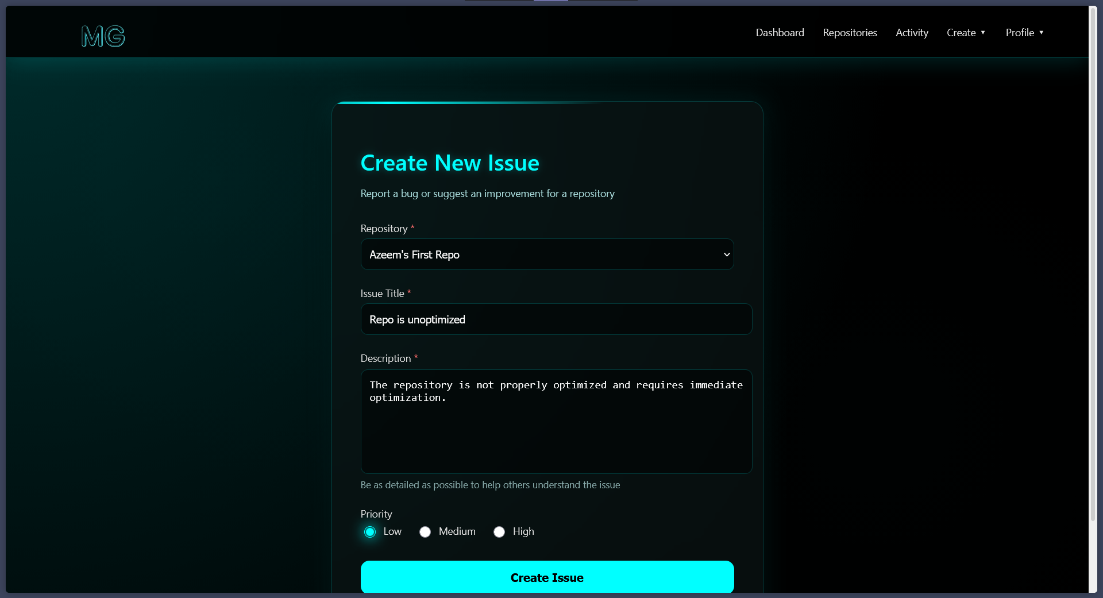

create_commit:
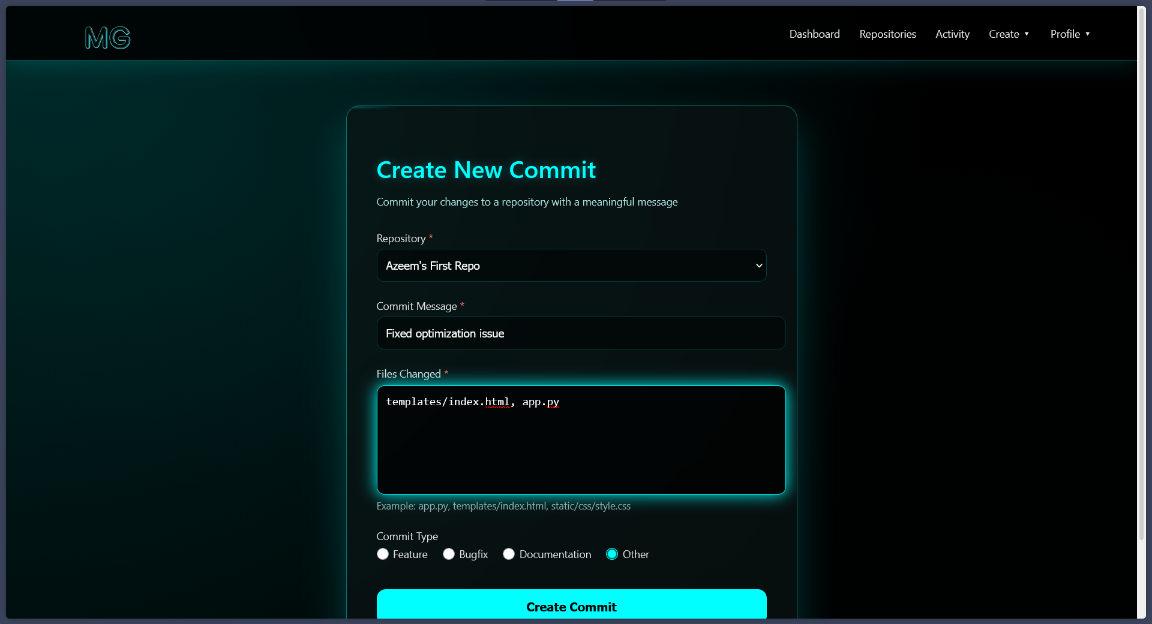

repositories.html:
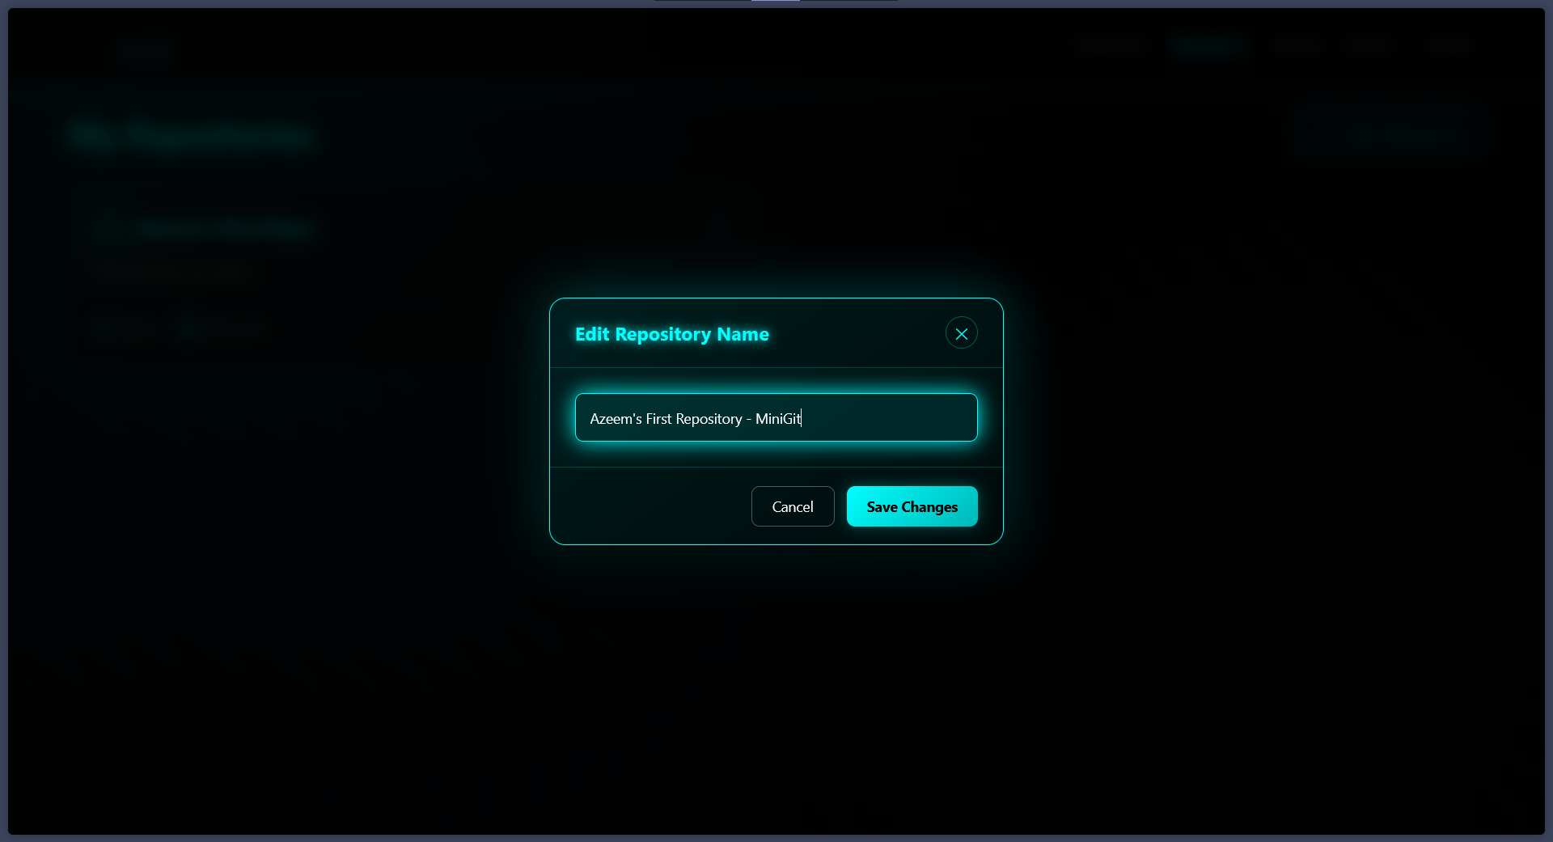

  - Output Design:
User Report:
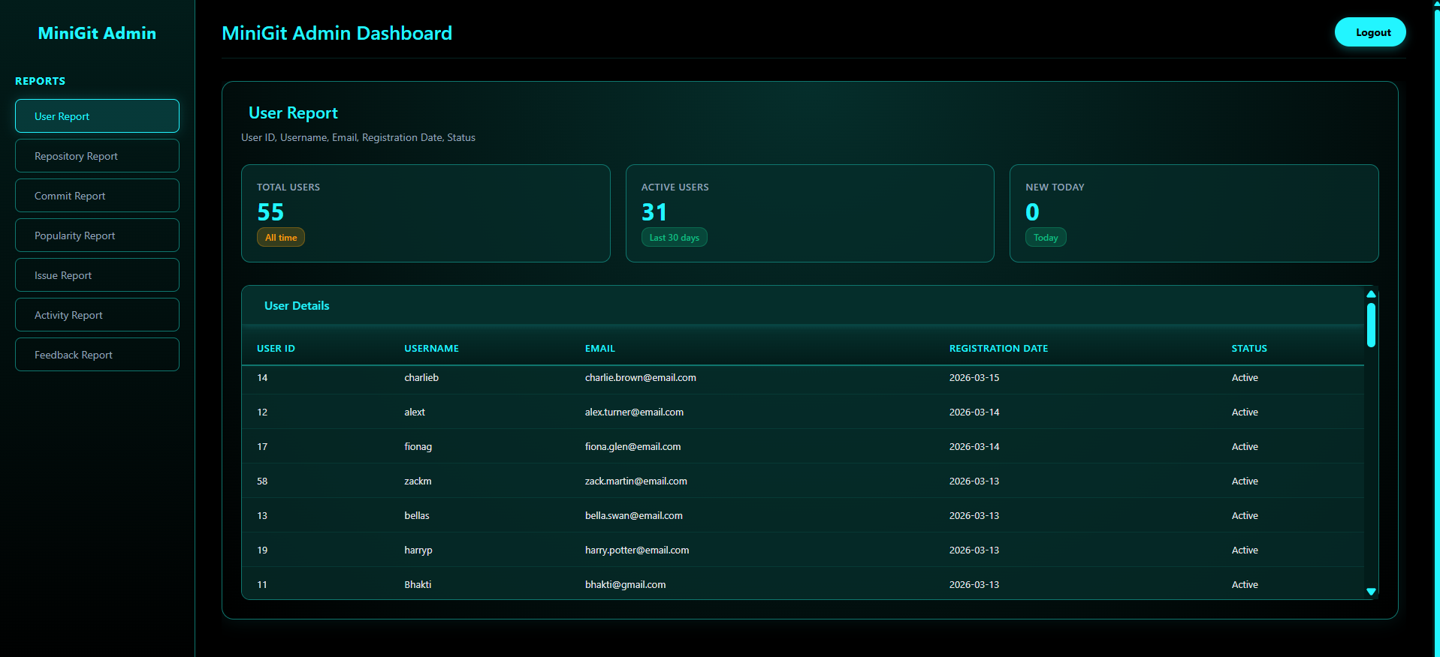

Repository Report:
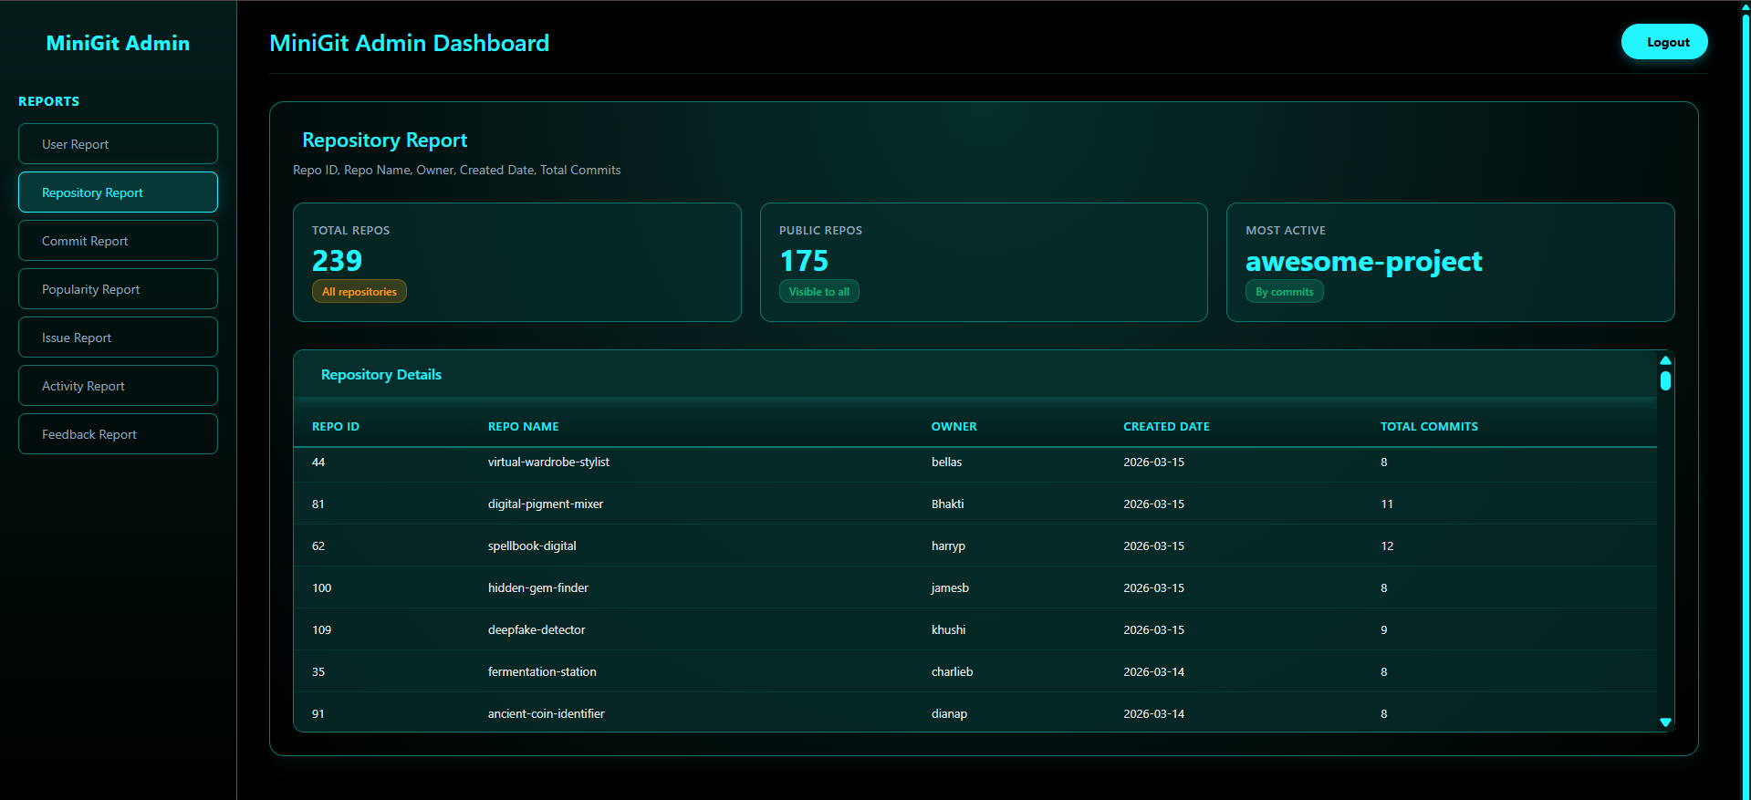

Commits Report:
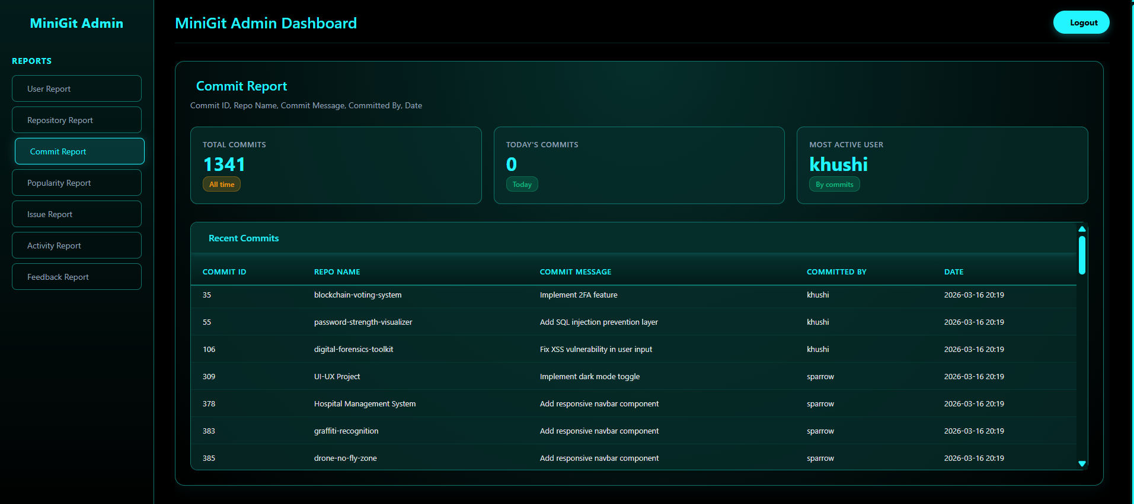

Popularity Report:
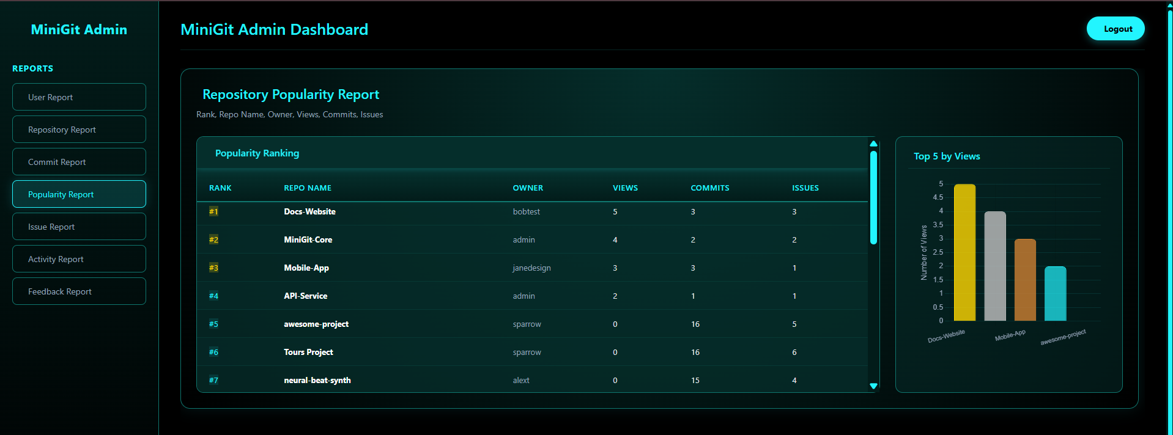

Issue Report:
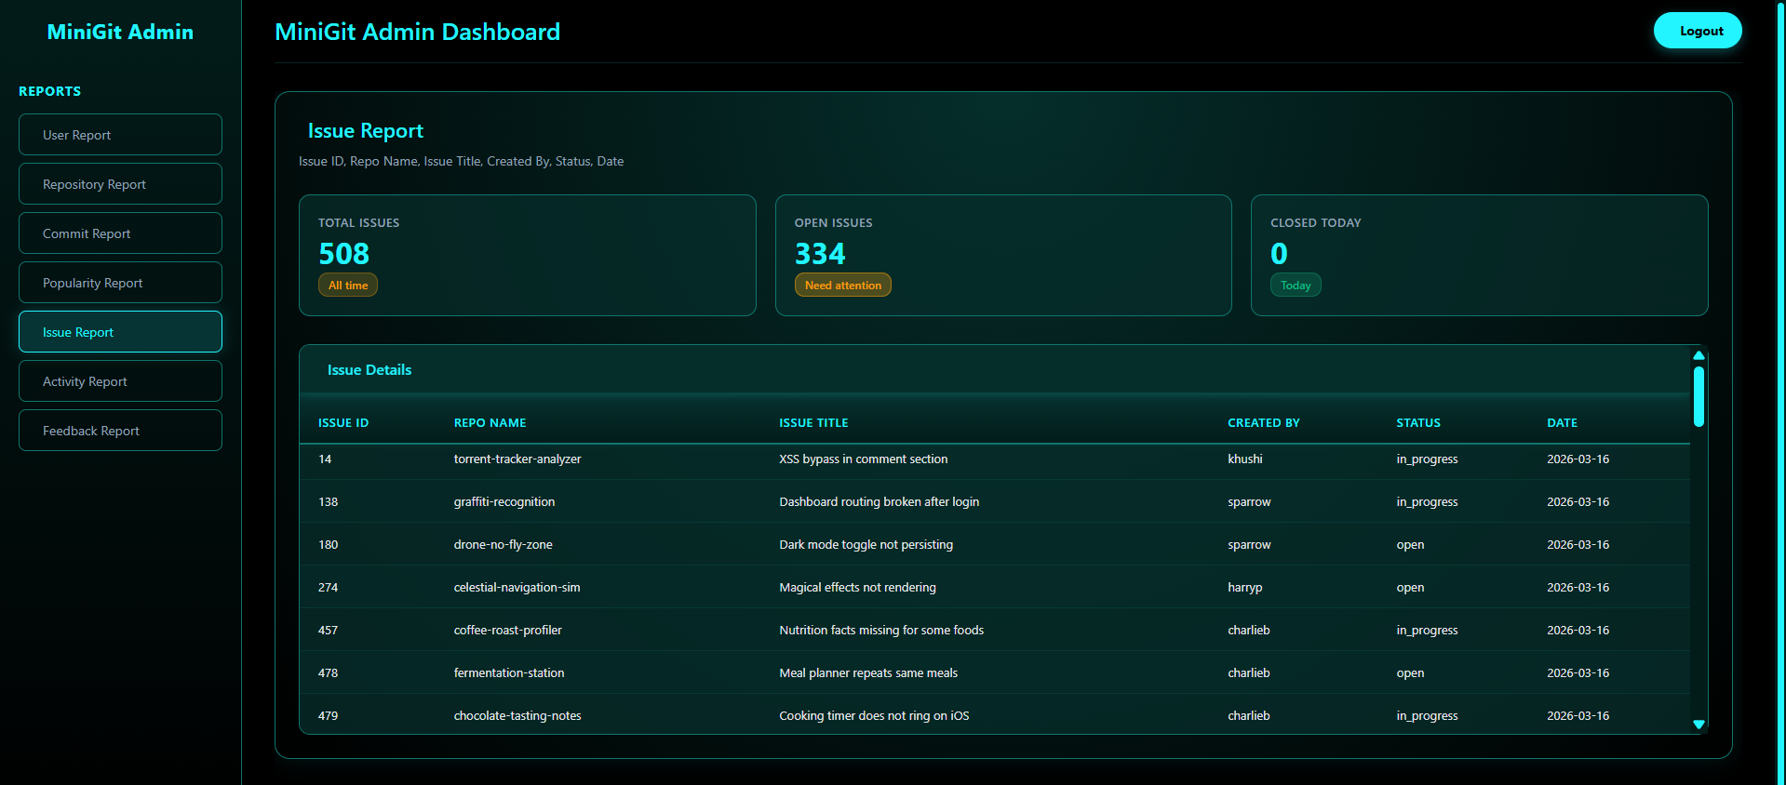

Activity Report:
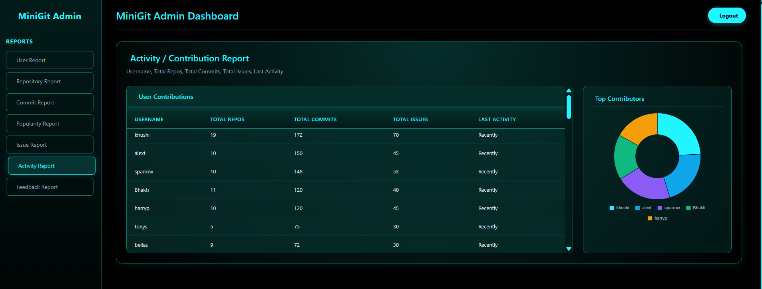

Feedback Report:
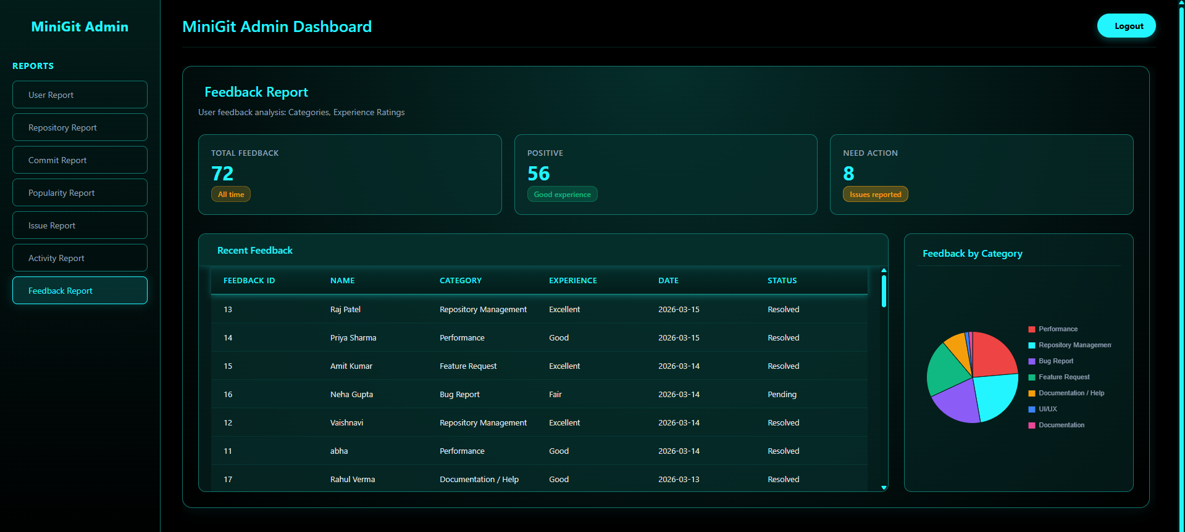

  - User Manual:

Sr. No. | Tab/Button | Description
1) |  | Allows user/admin login.
2) |    | Allows user to register.
3) | 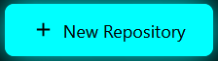   | Used to create repository.
4) |  | Used to create issue.
5) |  | Used to create commit.
6) | 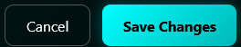 | Used to edit and save repo’s name.
7) |  | Used to submit feedback.

6.1 Conclusion:
In conclusion, MiniGit is a web-based version control management system developed using Flask and MySQL, designed to replicate the core functionalities of a modern source code hosting platform. The system enables users to create and manage repositories, track commits, raise and monitor issues, and engage with the platform through features such as repository starring and activity logging. By leveraging Flask as the backend framework and MySQL as the relational database, the project demonstrates the practical application of web development principles and structured data management in building a functional, multi-user software collaboration tool. MiniGit serves as a foundational implementation that reflects an understanding of user authentication, relational database design, and the organization of interconnected data entities in a real-world context.

6.2 Further Enhancements:
- Branch and merge management — The system could be extended to support the creation and merging of branches within repositories, allowing for a more complete and realistic version control workflow.
- Pull request system — A pull request mechanism could be introduced, enabling users to propose, review, and discuss code changes before they are merged into the main codebase.
- Collaborative access control — Role-based repository access could be implemented, allowing repository owners to add collaborators with varying levels of permissions such as read, write, or admin access.
- Anonymous feedback linkage — The current feedback module operates independently of the user system; linking it to authenticated users would enable more meaningful tracking and follow-up on submitted feedback.
- Notification system — A real-time or email-based notification system could be added to alert users of relevant activity such as new issues, commits, or stars on their repositories.
- Search and filtering — Enhanced search functionality across repositories, commits, and issues would significantly improve usability as the platform scales to accommodate a larger number of users and projects.

7.1 Bibliography:
Books Referred:
- Flask Web Development — Miguel Grinberg
- Database Management Systems — Ramakrishnan & Gehrke
- Database System Concepts — Silberschatz, Korth & Sudarshan

Website Referred:
- https://www.w3schools.com/
- https://www.google.com/
- https://www.youtube.com/

